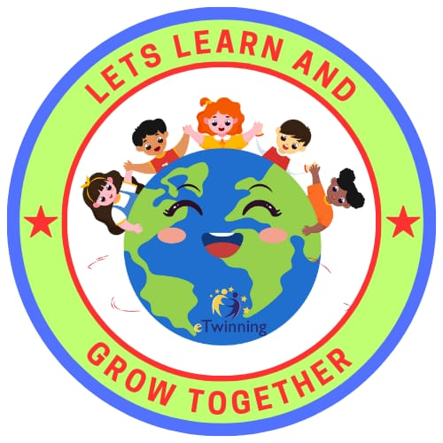
LET’S LEARN AND GROW TOGETHER eTWİNNİNG PROJECT
Our school’s 1-G class learns our values with the Let’s Learn and Grow together with my Values eTwinning Project.
The main purpose of the Project is;Today ,it is necessary to give the most in terms of achievement in raising people;to adopt concepts such as compassion helpfulness love and respect and to provide practical and effective achievements in assimilating these values in a way that will direct human life.Throughout our Project ,in line with these objectives,activities,studies will be held with our students within the scope of Values Education ,one every month.At the end of this Project,our students will be able to demonstrate in their own lives the values that will be based on real-life human relations,will create practical environments where they can experience concepts such as responsibilities towards nature ,love for animals and helpfulness.

